Name : Modi Tejasv M

Subject : python (task-2)

1. Write a python program to find whether the given number is perfect or not .

Ans:

var1=int(input("enter the number"))

sum=0

foriinrange(1,var1):

    if(var1%i==0):

        sum=sum+i

if(var1==sum):

    print("the number is perfect")

else:

    print("not a perfect number")

Output:

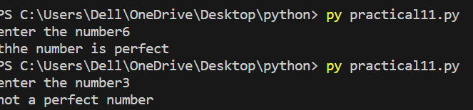

1. Write a python program to find the given number is palindrome or not .

Ans:

var=int(input("enter the number"))

t=str(var)

sum=0

while(var>0):

    r=var%10

    sum=(sum\*10)+r

    var=var//10

if(t==str(sum)):

    print("number is pellindrom")

else:

    print("nummber is not pellindrom")

Output:

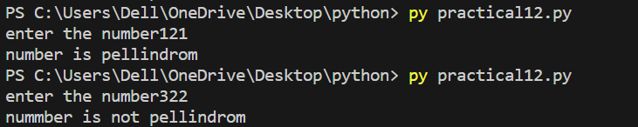

1. Write a python program to display the following pattern

\*

\*\*

\*\*\*

\*\*\*\*

\*\*\*\*\*

Ans:

foriinrange(1,7):

    forjinrange(1,i):

        print('\*',end="")

    print("")

Output:

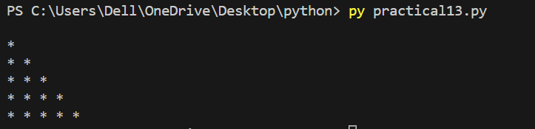

1. Write a python program to take two numbers from user and apply inbuilt function to find absolute of no, ceil of number , floor, max,min,power,sqrt,round off the two numbers.

Ans:

importmath

var1=int(input("enter the number 1 "))

var2=int(input("enter the number 2 "))

var3=int(input('enter the minus value '))

print("the absolute value of  number is ",abs(var3))

print("the ceil of  division is ",math.ceil(var1/var2))

print("the max number of this two number is ",max(var1,var2))

print("the min number of this two number is ", min(var1,var2))

print("the square root of this number is ",math.sqrt(var1))

print("the round of this division is ",round(var1/var2,1))

print('the floor of the division is ',math.floor(var1/var2))

Output:

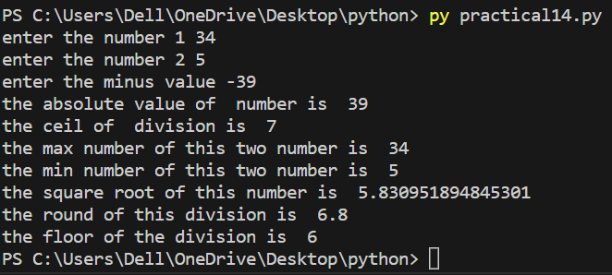

1. Write a python program to generate 20 numbers randomly in between 41 to 75.

Ans:

importrandom

count=0

foriinrange(41,75,1):

    if(count!=20):

         print(random.randrange(41,75,1))

         count=count+1

Output:

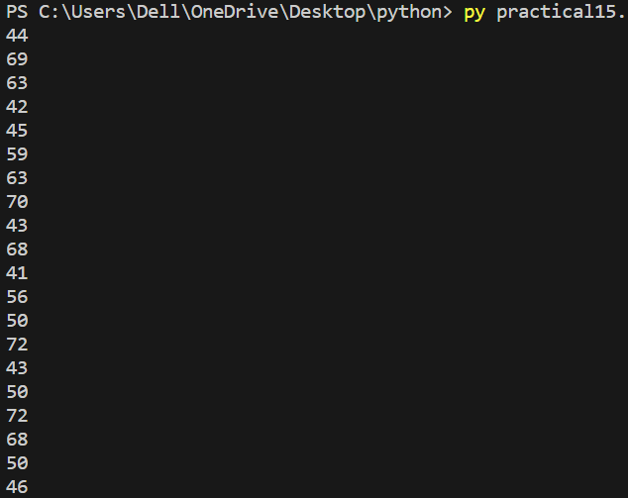

1. Write a python program to find input string is alphabet,numeric and alphanumeric or is space.

Ans:

var=input("enter the number or string ")

print("the string is ",var.isalpha())

print("the string is numeric",var.isnumeric())

print("the string is alphanumeric",var.isalnum())

print("the string is space ",var.isspace())

Output:

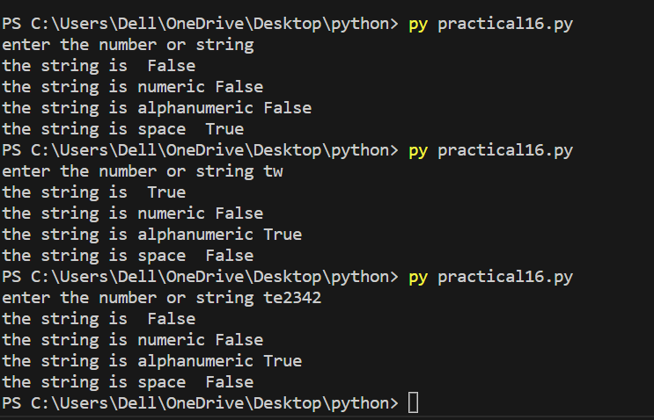

1. Write a python program to implements function on the string

- capitalize

- center

- count

- find

- lower

- upper

- replace

- split

- swap-case

Ans:

var=input("Enter the string ")

print("capitalize is ",var.capitalize())

print("center ",var.center(50))

print("count ",var.count("s"))

print("find ",var.find("tejasv"))

print("Upper ", var.upper())

print("Lower ",var.lower())

print("replce ",var.replace("Tejasv","kush"))

print("Split ",var.split())

print("Swap-case", var.swapcase())

Output:

